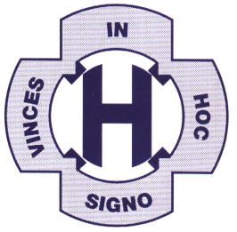

ST. HELEN’S CATHOLIC PRIMARY SCHOOL

JOB DESCRIPTION

MISSION STATEMENT

RESPECT YOURSELF,

RESPECT EVERYONE IN OUR SCHOOL COMMUNITY,

RESPECT EVERYONE IN OUR LOCAL COMMUNITY,

RESPECT EVERYONE IN OUR GLOBAL COMMUNITY
BUT MOST OF ALL, RESPECT GOD OUR FATHER
IN HEAVEN.

Job Title Kitchen Assistant

Grade

Reports to Cook

Liaison with Catering staff /MDAs

Job Purpose | To ensure that the kitchen and related areas are maintained in a clean and safe condition at all times; observing and maintaining food hygiene standards.
Duties | - To assist with service of meals to children  - To ensure that all pots, pans, cooking utensils and service counter containers are cleaned to the required standards and correctly stored after cleaning.  - Operating the dishwasher  - To maintain a high standard of personal and general cleanliness and hygiene to comply with statutory and school regulations.  - To attend training activities and/or meetings as required.  - Report immediately any accidents, fire, theft, loss, damage, unfit food or other irregularities.

GENERAL RESPONSIBILITIES FOR ALL SUPPORT STAFF

- To participate in the performance management process - taking personal responsibility for identification of your learning, development and training needs - in discussion with your Performance Management Team Leader.

- To comply with individual responsibilities, in accordance with role, for health and safety in the workplace.

- Ensure that all duties and services provided are in accordance with the school’s Equal Opportunities Policy.

The duties above are neither exclusive nor exhaustive and the post holder may be required by the Head Teacher to carry out appropriate duties within the context of their position.

THE GOVERNING BODY IS COMMITTED TO SAFEGUARDING AND PROMOTING THE WELFARE OF CHILDREN AND YOUNG PEOPLE AND EXPECTS ALL STAFF AND VOLUNTEERS TO SHARE IN THIS COMMITMENT.

