

Practise your spellings:
- Look, cover, write, check
- Learn the pattern
- Find more words and their meanings

CLIC
Look at your CLIC test, revise all the answers and correct any you got wrong.
Practise these style of questions more.



Please remember to read every day at home! Daily reading makes a big difference, try to read for at least 10-15 minutes each day.
Homework
Autumn 1
Practise your times tables.
Revise all times tables learnt so far: 2,3,4,5,8,10
Learn 6x table
Link times tables to division to build your understanding of ‘fact families’.
https://www.bbc.co.uk/bitesize/articles/z97rdnb#zmsqtcw
https://www.topmarks.co.uk/maths-games/hit-the-button



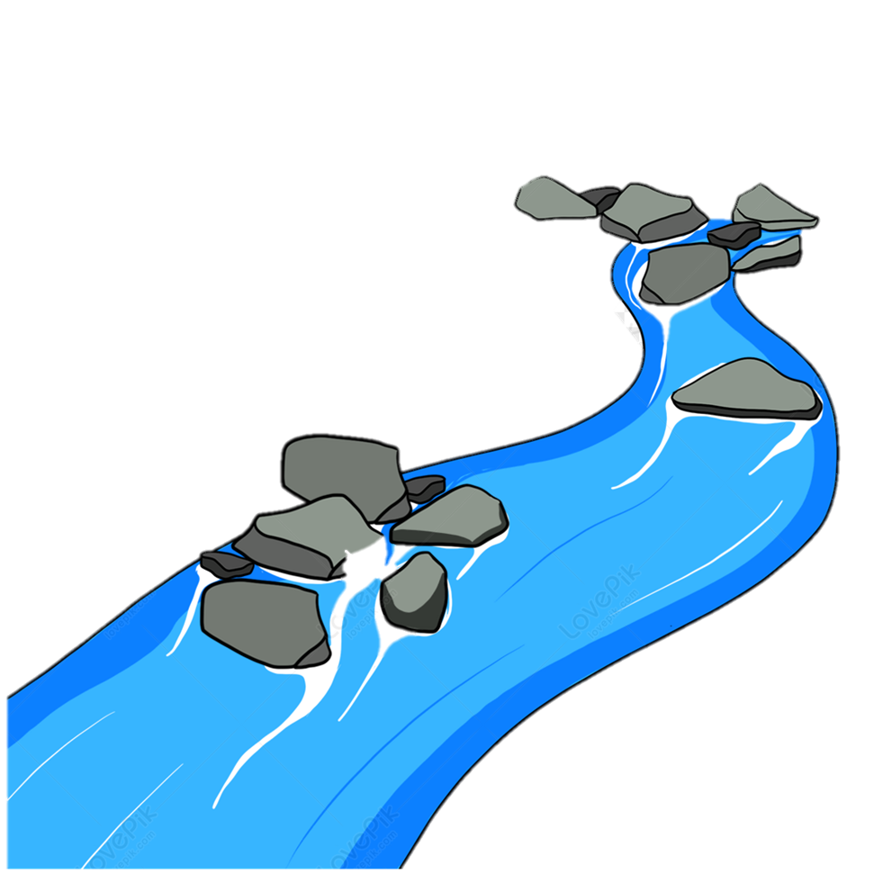
Topic – Rivers:
Choose to complete one activity. Complete more if you wish.
Research an important River in the world:
Choose your median – fact file, poster, power point.
Tell us facts, location, why it’s important?
Draw and label or make a model showing the parts of a river
eg – meander, ox-bow, estuary, bank,
Paint/draw a rivers picture in the style of John Constable.

